**PRACTICAL 6**

**Database Management Systems**

|  |  |
| --- | --- |
| **NAME: VARUN KHADAYATE** | **ROLL NO: A016** |
| **PROGRAM: BTECH SY** | **DIVISION: CSBS** |
| **BATCH: 1** | **DATE OF EXPERIMENT: 22/03/2021** |

# AIM

Consider the MOVIE DATABASE

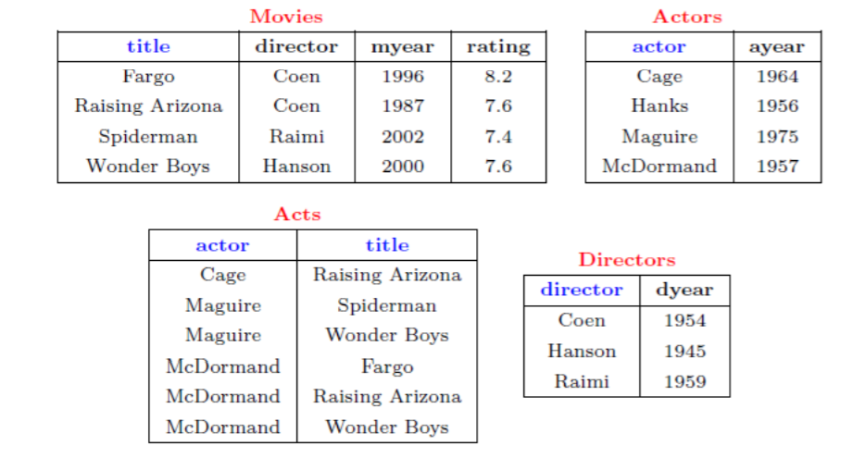

Write following relational algebra queries for a given set of relations.

1. Find movies made after 1997
2. Find movies made by Hanson after 1997
3. Find all movies and their ratings
4. Find all actors and directors
5. Find Coen’s movies with McDormand

# SNAPHOTS

## Find movies made after 1997

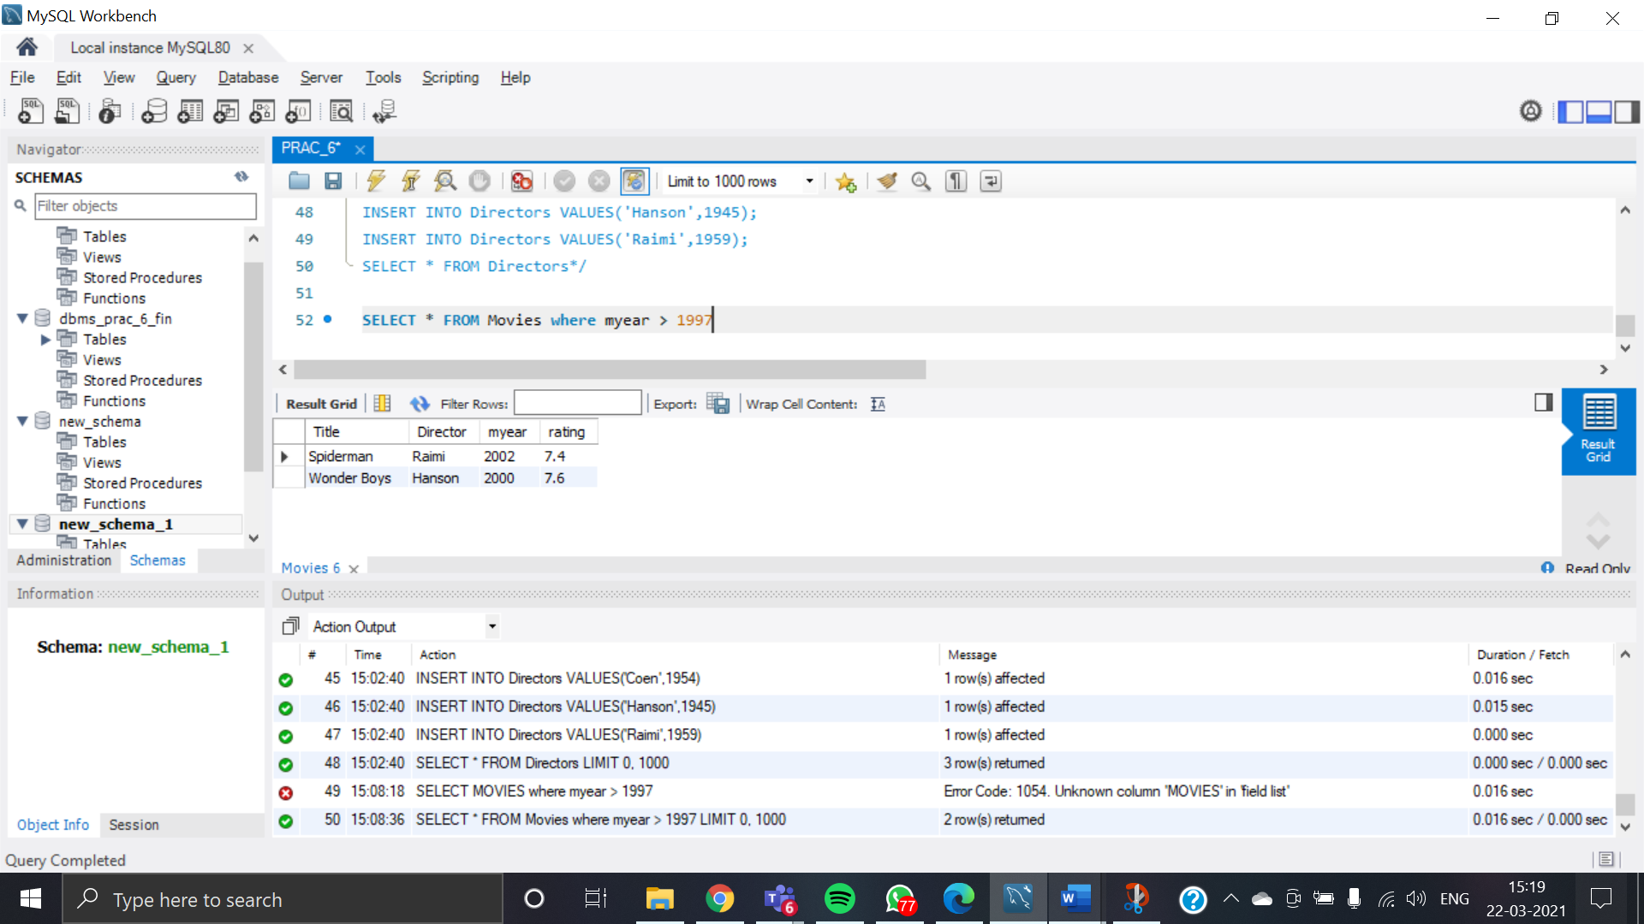

## Find movies made by Hanson after 1997

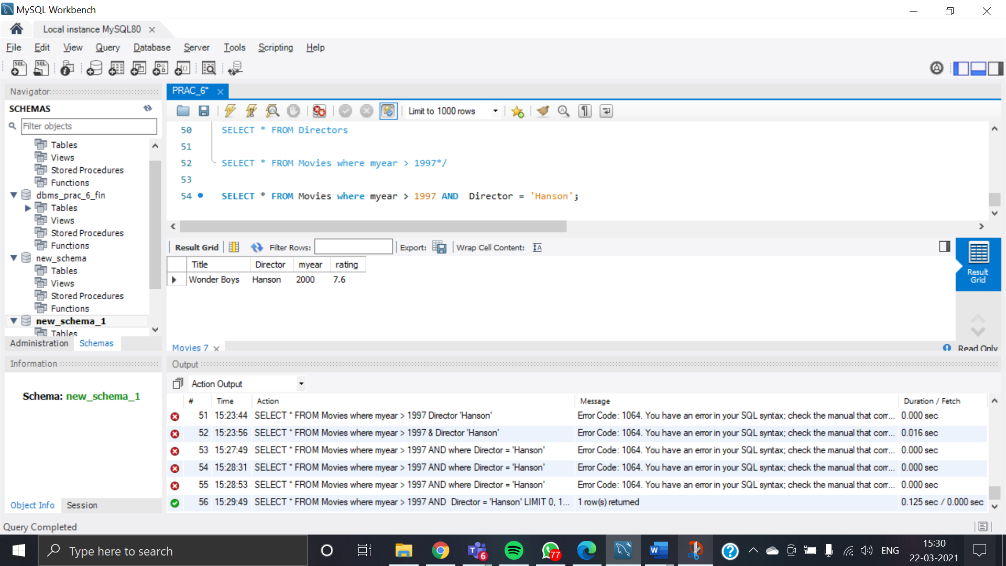

## Find all movies and their ratings

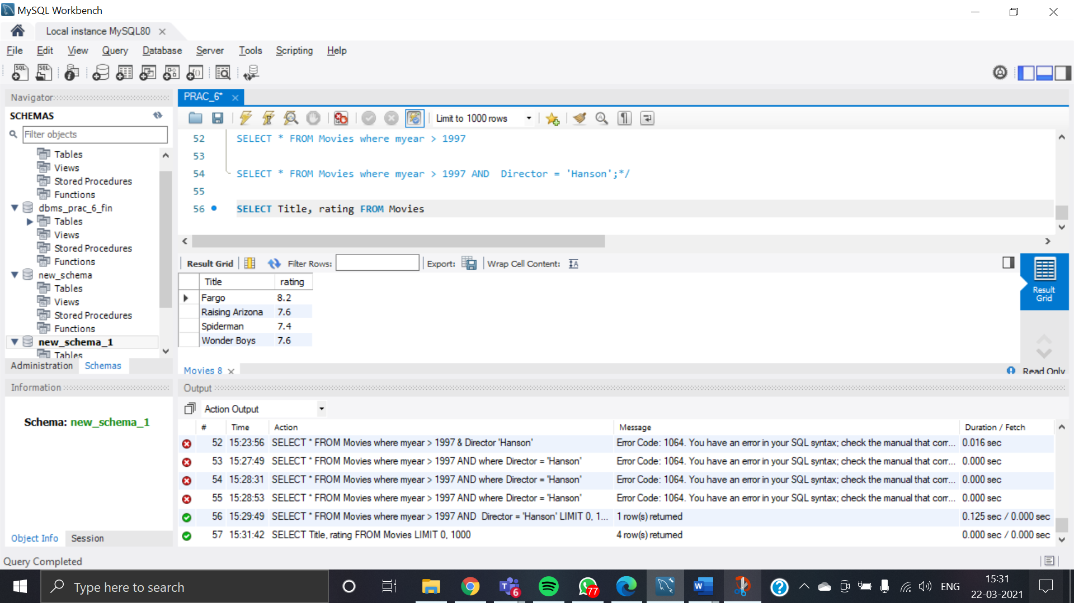

## Find all actors and directors

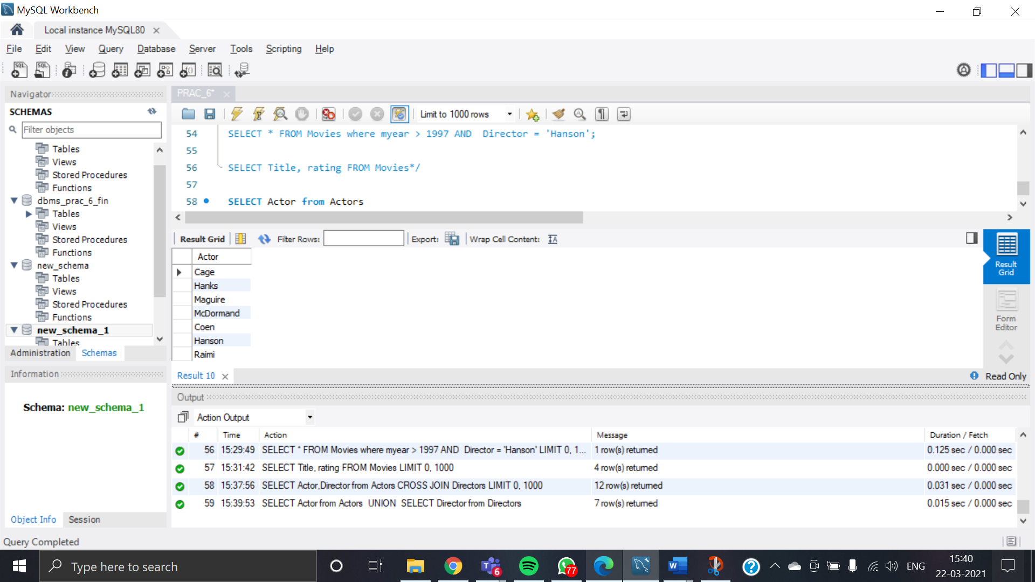

## Find Coen’s movies with McDormand

